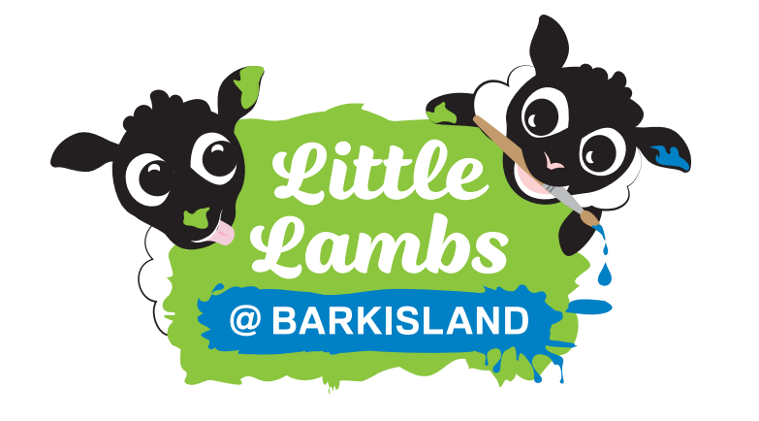
Barkisland Little Lambs
Nursery Application Form 2025/2026
January 26 Intake
CHILD’S DETAILS
CHILDS SURNAME: |  |  |  |  | FORENAMES:
DATE OF BIRTH:  (ENCLOSE COPY OF BIRTH CERTIFICATE) |  |  |  |  | GENDER: |  |  | MALE |  |  |  |  | FEMALE
HOME ADDRESS (INC. POSTCODE)
DETAILS OF THE PARENTS/CARERS WITH PARENTAL RESPONSIBILITIES
TITLE: |  | SURNAME: |  |  |  |  |  | FORENAME:
RELATIONSHIP TO THE CHILD:
HOME ADDRESS (IF DIFFERENT TO CHILD):
EMAIL ADDRESS:
DAY TIME TELEPHONE NUMBER: |  |  |  | WORK TELEPHONE NUMBER: |  |  |  |  |  |  | MOBILE TELEPHONE NUMBER:
TITLE: |  | SURNAME: |  |  |  |  |  | FORENAME:
RELATIONSHIP TO THE CHILD:
HOME ADDRESS (IF DIFFERENT TO CHILD):
EMAIL ADDRESS:
DAY TIME TELEPHONE NUMBER: |  |  |  | WORK TELEPHONE NUMBER: |  |  |  |  |  |  | MOBILE TELEPHONE NUMBER:
DETAILS OF ANY SIBLINGS ATTENDING BARKISLAND CE (VA) SCHOOL AT THE TIME OF ADMISSION
CHILD’S NAME: |  |  |  |  |  | DATE OF BIRTH:
CHILD’S NAME: |  |  |  |  |  | DATE OF BIRTH:
CHILD’S NAME: |  |  |  |  |  | DATE OF BIRTH:
FURTHER INFORMATION TO SUPPORT YOUR APPLICATION
PLEASE STATE IF YOUR CHILD HAS AN EDUCATION HEALTH CARE PLAN |  |  |  |  |  |  |  |  | YES |  |  |  |  | NO
PLEASE STATE IF YOUR CHILD IS: (only complete if applicable)
IN PUBLIC CARE
ADOPTED
CARED FOR UNDER A SPECIAL GUARDIANSHIP ORDER

PLEASE STATE IF YOU OR YOU ARE APPLYING FOR A PLACE UNDER CHURCH AFFILLIATION |  |  |  |  |  |  |  |  | YES |  |  |  |  | NO
PLEASE NOTE THAT IF YOU ARE APPLYING UNDER CHURCH AFFILLIATION YOU WILL ALSO NEED TO COMPLETE A SIF FORM WHICH CAN BE OBTAINED FROM OUR SCHOOL OFFICE / WEBSITE (UNDER THE ADMISSIONS TAB)
FREE ENTITLEMENT REQUIREMENTS: 15 Hours funding only

The free 15 hours can be used during any of the following sessions (the full session hours have to be used)
Other childcare sessions can be booked as a chargeable service (spaces permitting).

Please indicate your preferred sessions:

 | MONDAY | TUESDAY | WEDNESDAY | THURSDAY | FRIDAY
KIDS CLUB AM
1¼ hours
(7:30am-8.45am)

MORNING
3 hours
(8:45am-11:45am)

AFTERNOON
3 hours
(12:30pm-3:30pm)

LUNCH
45 minutes
(11:45am-12:30am)
FULL DAY
6 hours
(8.45pm -2.45pm)

END OF DAY
45 minutes
(2.45pm-3.30pm)

KIDS CLUB PM
2½ hours
(3.30pm-6.00pm)

TOTAL HOURS
(not exceeding 15 hours)

Will your child be receiving any part of their free entitlement at another provider? YES / NO

If YES, where? ……………………………………………………………………………………………….……………

For how many hours?........................................................

FREE ENTITLEMENT REQUIREMENTS: 30 Hours funding (if eligible)
The free 30 hours can be used during any of the following sessions (the full session hours have to be used)
Other childcare sessions can be booked as a chargeable service (spaces permitting).

Please indicate your preferred sessions:

 | MONDAY | TUESDAY | WEDNESDAY | THURSDAY | FRIDAY
KIDS CLUB AM
1¼ hours
(7:30am-8.45am)

MORNING
3 hours
(8:45am-11:45am

AFTERNOON
3 hours
(12:30pm-3:30pm)

LUNCH
45 minutes
(11:45am-12:30am)
FULL DAY
6 hours
(8.45pm -2.45pm)

END OF DAY
45 minutes
(2.45pm-3.30pm)

KIDS CLUB PM
2½ hours
(3.30pm-6.00pm)

TOTAL HOURS
(not exceeding 30 hours)

Will your child be receiving any part of their free entitlement at another provider? YES / NO

If YES, where? ……………………………………………………………………………………………….……………

For how many hours?........................................................

CHARGEABLE CHILDCARE
Where spaces permit, parents/carers are able to request additional sessions for their child to supplement their free entitlement of 15 or 30 hours per week.

Additional Charges:
Morning / Afternoon session | £21
Kids Club – Before School | £6.00
Kids Club – After School | £11.00
Lunch (meal chargeable if not bringing packed lunch) | £2.75
Lunch session including meal (only offered if requesting with a morning or afternoon session only) | £8.00 (£2.75 lunch & £5.25 session)
End of Day session between 2.45 pm (nursery full day session closes) and 3.30 pm (school day closes) | £5.25

I would also like to request (space permitting) the following chargeable childcare sessions:

 | MONDAY | TUESDAY | WEDNESDAY | THURSDAY | FRIDAY
KIDS CLUB AM
1¼ hours
(7:30am-8.45am)
MORNING
3 hours
(8:45am-11:45am
AFTERNOON
3 hours
(12:30pm-3:30pm)
LUNCH
45 minutes
(11:45am-12:30am)
FULL DAY
6 hours
(8.45pm -2.45pm)
END OF DAY
45 minutes
(2.45pm-3.30pm)
KIDS CLUB PM
2½ hours
(3.30pm-6.00pm)
TOTAL HOURS

Please use the space to share any other information that you may feel relevant to support your application.
If you have any flexibility with sessions requested, please use this space to detail this.

N.B Admission to the nursery at Barkisland CE VA Primary School does not guarantee an automatic place in the school’s Reception class.

Name: ……………………………………………………………… Relationship to child ………………………………………………
Signed:…………………………………………….………………… Date:…………………...……………..………….
Return to: Barkisland CE (VA) School, Scammonden Road, Barkisland, Halifax, HX4 0BD
Or email: admin@barkisland.calderdale.sch.uk By Friday 26th September 2025
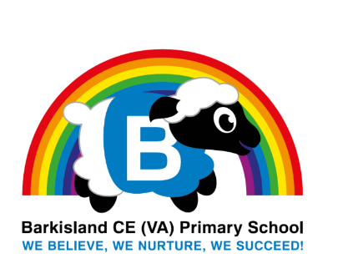
If you have any further questions, please contact the school by email or telephone (01422 823324)

