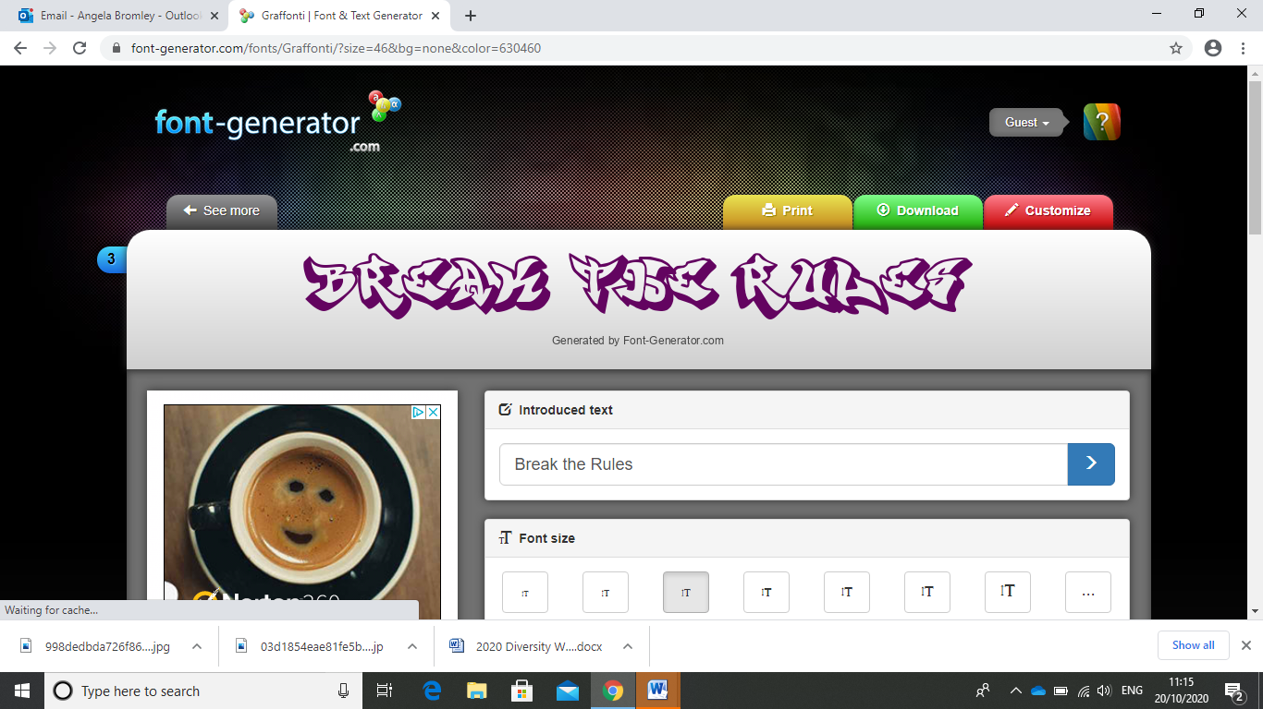
Break the Rules Day – Friday 6th June 2025
25p each
Crazy hair (any style, any colour)
Trainers/other footwear
No uniform (top)
No uniform (bottom)
Wear nail varnish
Wear jewellery
Bring in a small toy/teddy to sit on desk
Eat pudding first
Unhealthy snacks at break (no nuts please)
Contraband in water bottles
(not fizzy please)
Tick the end column for the rules you want to break. Work out your total fine and make sure you bring in correct change

Please consider the weather and that children will play outside on the playground, trim trail or field – clothing and footwear should be appropriate for this.
Name: _______________________________ Class: _____________
Total Fine To Pay: ________

