**End of Year Treat Fundraiser - Friday 6th June 2025**

Over the past few weeks representatives from each class have been meeting to discuss our latest Pupil Voice initiative – The End of Year Treat! The children shared some fantastic ideas for raising money within school and had some great (and wacky) thoughts as to what the whole school end of year treat could be.

Whilst planning for the treat day is still ongoing, we have planned two fundraisers which we hope you can support. Both will take place on **Friday 6th June 2025**.

Our first fundraiser will be **Break the Rules Day**. Children can choose which rules they would like to break from the list – they can break one rule or several. For every rule broken we ask that you donate 25p. Not all rules are breakable, however, so please read the information below and overleaf carefully. The children have suggested a very interesting list of rules they would like to break, which the senior leadership team have then whittled down to a workable list. Normal school rules apply, unless they are on the list on the back of this letter. Please be mindful if your child has PE to dress appropriately and no colours in the hair if your child has swimming.

All donations will go straight towards the whole school end of year treat. When you have agreed which rules your child will break, please work out the total fine and complete the form overleaf. All donations need to be in exact money, as no change can be given. We can, however, take single payments for siblings – just pop a note in with the donation if you are doing this. Please send this form back with your child so that can hand it over with their donation.

In addition to this, we will be holding a **bake sale** after school from 3.30pm to 4pm in the KS2 playground. We would appreciate donations of bakes. Please can these be brought in on the morning of Friday 6th June. Remember, we are a nut free school. This will be a cash only stall so please bring change.

We hope you can support our fundraising efforts so the children can enjoy a special treat at the end of the academic year!

With thanks,

Mrs Nicoll (Pupil Voice Lead)

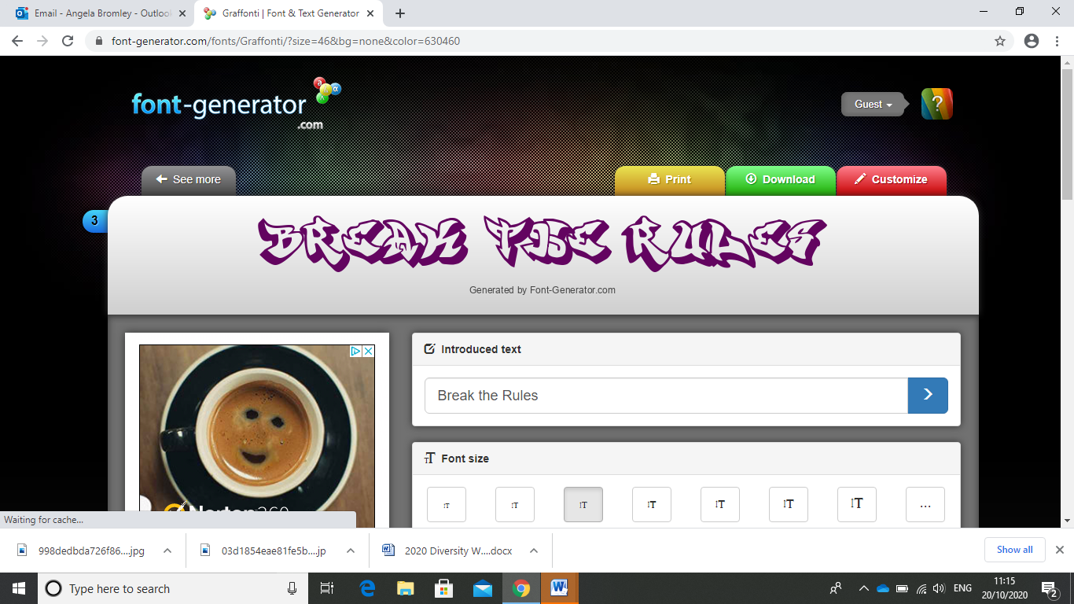

**Break the Rules Day –**

**Friday 6th June 2025**

Tick the end column for the rules you want to break. Work out your total fine and make sure you bring in correct change

|  |  |
| --- | --- |
|  | 25p each |
| Crazy hair (any style, any colour) |  |
| Trainers/other footwear |  |
| No uniform (top) |  |
| No uniform (bottom) |  |
| Wear nail varnish |  |
| Wear jewellery |  |
| Bring in a small toy/teddy to sit on desk |  |
| Eat pudding first |  |
| Unhealthy snacks at break (no nuts please) |  |
| Contraband in water bottles (not fizzy please) |  |

Please consider the weather and that children will play outside on the playground, trim trail or field – clothing and footwear should be appropriate for this.

Name: _______________________________ Class: _____________

Total Fine To Pay: ________