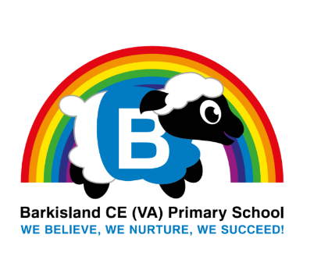t

What does SEN really mean?

If your child has been entered onto our school SEN register by, you may be wondering what exactly it is and what it will mean for your child throughout their education and into their adulthood. In very simple terms, SEN stands for ‘Special Educational Needs’. When pupils are assessed for special educational needs, it’s vital to find out how they learn and how they can be assisted to learn. By doing this it can be the difference between education being ‘difficult’ and education being ‘different’.

Some ‘Special Educational Needs’ currently recognised in the UK are Autism Spectrum Condition (ASC), Specific learning difficulties (Dyslexia, Dyspraxia, Dysgraphia, Dyscalculia), Attention Deficit Hyperactivity Disorder (ADHD), Specific Medical Needs and other Mental Health Issues.

SEN pupils may require a different teaching approach from other pupils and, in most cases, they will need a different lifestyle approach too, to help them reach their full potential. **It is important to note**thatmany pupils with SEN are not ‘unable’ to do their work. In fact, many are just as intelligent on a cognitive scale, and some even more so than their neurotypical peers. It’s just a case of finding out how they learn so that we can best embrace that and help them to flourish!

Calderdale SENDIASS

*‘Helping Families with the Road Ahead’*

The SEND Information, Advice and Support Service (SENDIASS) is a great website for parents and carers to visit if you need  legally based, impartial, confidential and accessible information, advice and support for your child with Special Educational Needs or Disabilities about education, health and social care. They can offer face to face, telephone and electronic information advice as well as casework and representation if needed.

A wealth of advice and support can be found on the website, including;

* A guide to the sections in an EHCP (Education, Health and Care Plan)
* Helping young people to give their own views and aspirations
* SEN Support fact sheets

Please visit <https://www.calderdalesendiass.org.uk/parents-and-carers-information/> if you feel that this would be useful for you and your family.

How to support your child at home

Research and studies have shown that the most important thing you can do to support your child’s education at home is to read little and often.

If your child has an ISP in place this document will provide you with targets you can also use at home to support your child’s learning at school. These are updated at least termly.

If you have any questions about supporting your child at home please don’t hesitate to contact your child’s teacher.

SEN Documents

All required SEN Documentation is available on our school website.

From the homepage select ‘Curriculum’ then ‘Inclusion’.

Written By Mrs Howarth, Inclusion Manager

Inclusion Manager Role

Hello, my name is Mrs Howarth and I am the Inclusion Manager at Barkisland. It is my responsibility to co-ordinate an effective service for children with Special Educational Need and Disability throughout our school. I monitor and update the SEN Register for the school, and monitor individual children and their progress once they have been placed on the register. I recently achieved the National Award for SEN Co-ordination which has already began to have a positive impact on my SEN leadership at Barkisland.

I also work closely with Mrs Young, our Pastoral Support Worker, who does valuable work to support children and their families when needed.

If you would like to speak to either of us, then please email ([admin@barkisland.calderdale.sch.uk](mailto:admin@barkisland.calderdale.sch.uk)) or phone 01422 823324.

**Barkisland SEND Bulletin**

Autumn Term 2023